**Bellabeat Marketing Strategy Report**

**1. Introduction**

Bellabeat is a high-tech company focused on health and wellness products for women. This case study aims to analyze user activity trends using Fitbit data to provide actionable insights for Bellabeat’s marketing strategy.

**2. Data Preparation & Cleaning**

* Checked for duplications and null values
* Identified and corrected outliers and inconsistent values
* Converted data types appropriately
* Ensured timestamps were in the correct format

**3. Exploratory Data Analysis (EDA)**

**Key Analysis Performed:**

* Track the number of active days per user
* Calculate daily engagement rate
* Identify drop-off patterns
* Identify returning users

**4. Data Visualization & Insights**

**Daily Engagement Rate Analysis**

**Visualization:**

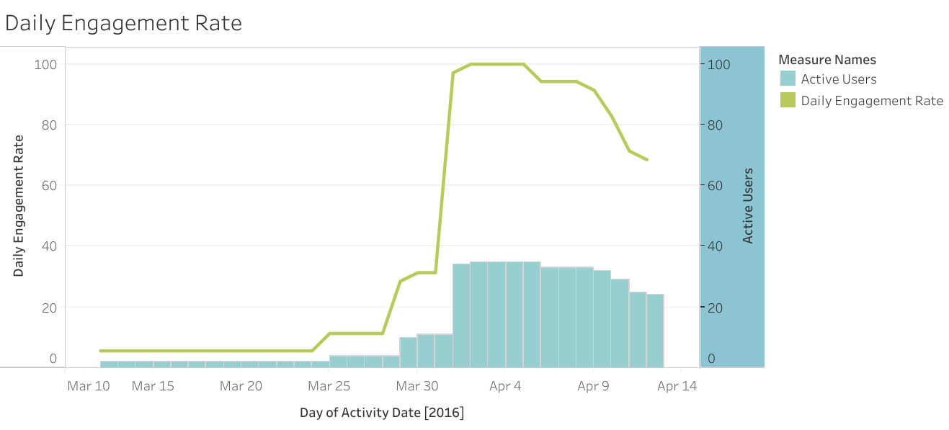

**Key Findings:**

* The **daily engagement rate** remained very low (~5.71%) from **March 12 to March 24**, indicating a lack of active users.
* A **gradual increase** in active users started around **March 25**, with engagement reaching **31.43% by March 31**.
* On **April 1, engagement peaked at 97.14%**, followed by **100% participation from April 2 to April 5**.
* After April 5, engagement showed a **declining trend**, dropping to **68.57% by April 12**.

**Marketing Implications:**

* The engagement surge in early April suggests a **successful campaign or feature launch**. Bellabeat should investigate what caused this increase and replicate similar strategies.
* The **drop in engagement post-April 5** indicates potential retention issues. A follow-up campaign (e.g., reminders, challenges, or incentives) could help maintain active users.
* Continuous monitoring of engagement patterns will allow Bellabeat to optimize marketing efforts and improve long-term user retention.

**5. Recommendations**

* Implement a **loyalty program** to sustain high engagement levels.
* Use **push notifications** and in-app challenges to encourage daily activity.
* Analyze user feedback around April 1-5 to understand what drove engagement.
* Personalize marketing strategies based on user consistency trends.

**6. Conclusion**

Analyzing user activity trends has provided valuable insights into user engagement patterns. By leveraging these insights, Bellabeat can optimize its marketing strategy to improve user retention and drive brand growth.